**Chapter 1: Harmony in Family – Understanding Values in Human Relationships**

Family, as defined by a ***1970s Long Island, New York Housing Code*** (upheld by the ***U.S. Supreme Court in 1974***): **“One or more persons related by blood, adoption or marriage, living and cooking together as a single housekeeping unit, exclusive of household servants.”**

Oxford English dictionary defines family as **“a group of persons consisting of the parents and their children, whether actually living together or not.”** Family is a group of people or animals (many species form the equivalent of a human family wherein the adults care for the young) affiliated by consanguinity (Relationship by blood or by a common ancestor), affinity or co-residence. Although the concept of consanguinity originally referred to relations by “blood”, anthropologists have argued that one must understand the idea of “blood” metaphorically and that many societies understand family through other concepts rather than through genetic distance.

## Family as a basic unit of interaction

The family is a natural laboratory and learning ground:

1. To understand the harmony in relationship with human beings and
2. To practice it in terms of its fulfillment, evaluation, and ensuring mutual happiness before we extend this to every unit in the society and then to nature.

## Harmony in the family

The family is the basic unit of human interaction, it is the anchor that roots us, it gives us both roots to hold and wings to fly. It is not surprising that children who grow up in happy families are more successful and well-adjusted in life.

Family relations can give us the strength to face the world. How wonderful it feels to return to a happy home after a hard day at work? Our family can be our sounding board to bounce off creative ideas, our greatest supporter during adversity, and the source of unconditional love. Now imagine a situation where there are very unpleasant relations at home – bitter fights, jealousies, and the blame game being played out! A person would actually hate going home in such an oppressive atmosphere.

Family feuds can cause depression, anxiety, sleeplessness, loss of appetite, sadness, confusion, and rage. No one wants to live like that! Here are some simple rules for turning family feuds into family fun.

1. Parents are very important element of the family. The prime responsibility to run smooth family relation lies on the shoulder of parents so they need to extra cautious. Parents are the real role models for the kids. They look at them with great hope. Their well-being depends largely on parents’ conduct.
2. Children need strong emotional support along with adequate monetary support. The wording like – “don’t worry my son, work hard we are with you” can bring wonderful results. Healthy family environment is essential requirement for a well-knit family.
3. Old generation like grandfather and mother are the real assets to the family. Complete respect can be translated to very good guidance for every member of the family. Remember they carry a very rich experience with them that one can only get after spending so much time in life.
4. The problem with relations is that even if we do not like we have to live with them. The best way is to avoid any kind of disconnect and establish dialogue.
5. Family harmony is the basic foundation on which the entire edifice of social harmony is built.

There is a set of proposals about the families for us to verify:

1. **Relationship IS and it exists between the self (‘I’) and the other-self (‘I’).**
2. **The self (‘I’) has FEELINGS in a relationship. These feelings are between ‘I’ and ‘I’.**
3. **These feelings in the self (‘I’) are DEFINITE. i.e. they can be identified with definiteness.**
4. **RECOGNIZING and FULFILLING these feelings leads to MUTUAL HAPPINESS in a relationship.**

Now, we will explore each of the above in detail.

### 1. Relationship IS and it exists between the self (‘I’) and the other-self (‘I’).

Once we have recognized the existence of human relationships, we are subsequently able to identify the feelings (values). When we work and behave according to these feelings, it leads to the fulfillment of both sides in the relationship, i.e. it leads to mutual fulfillment. Evaluation is a natural process when we live in relationships and we constantly evaluating our and the other’s feelings in the relationship. For example, trust is wanted in a relationship and if there is a mutual feeling of trust, then it leads to mutual fulfillment and there are no complaints. But if there is doubt on the other, the happiness in a relationship is missing.

It is not possible to create the relationships that are existent in a family. We are naturally born into this. In a similar way, the family has not invented the social dependencies in which it exists. The family exists naturally as a part of this social web of interdependency. So, we are embedded in relationships, they are there and all that we need to do is to recognize them and understand.

### 2. The self (‘I’) has feelings in a relationship. These feelings are between ‘I’ and ‘I’.

There are feelings in relations naturally. They do not have to be created, nor can we remove them. We may try to suppress them, or argue against them, or undermine them, but they are very much there. These feelings are fundamental to the relationship and can be recognized. Let’s ask some questions:

**Question: Who has these feelings? ‘I’ or body?**

**Answer:**‘I’

**Question: With whom does ‘I’ have these feelings? With the order ‘I’ or the other body?**

**Answer:**With the other ‘I’.

**Question: Who wants trust in a relationship? Our Self or body?**

**Answer:** Self wants trust.

**Question: From whom we want this trust? The other ‘I’ or Body?**

**Answer:** From the other ‘I’.

This is something we can easily verify ourself, that it is ‘I’ that wants trust. There is no part of the body that wants trust, no part of the body that wants respect. When we respect someone, we respect the person’s ‘I’, and not their body organs. When we ‘trust’ someone, it is the person and not the body. Trust is something to do with the person, the self (‘I’). That is to say, the feelings in a relationship are between ‘I’ and ‘I’.

### 3. These feelings in the self (‘I’) are definite. i.e. they can be identified with definiteness.

With a little exploration, we can see that feelings in relationships are actually definite, and not vague. These are the values characterizing relationships – e.g. Trust, Respect, Affection, etc. Living with these values, we are able to participate in the right way with other human beings.

### 4. Recognizing and fulfilling these feelings leads to mutual happiness in a relationship.

Once we have recognized the existence of human relationships, we are subsequently able to identify the feelings (values). When we work and behave according to these feelings, it leads to fulfillment of both sides in the relationship, i.e. it leads to mutual fulfillment. Evaluation is a natural process when we live in relationships and we are constantly evaluating ours’ and the other’s feelings in the relationship. For example, trust is wanted in a relationship and if there is a mutual feeling of trust, them it leads to mutual fulfillment and there are no complaints. But if there is doubt on the other, the happiness in relationship is missing.

To summarize – relationships in a family or in a society are not created, they just are. We can understand these relationships and based upon this understanding, it will be natural to have right feelings (values) in these relationships. These feelings are definite and can be recognized with certainty. We have also seen that recognizing the relationship and having the feelings in relationship is an activity of the self (‘I’) and not the body. It becomes clear that relationship is between the self (‘I’) and other self (‘I’) and the feelings are also between ‘I’ and ‘I’. Mutual fulfillment is the natural outcome of a relation correctly recognized and lived.

**Justice (Nyay)**

***“Justice is the recognition of values (the definite feelings) in a relationship, their fulfillment, the right evaluation of the fulfillment resulting in mutual happiness.”***

Justice concerns itself with the proper ordering of things and people within a society.

**Elements of justice**

**There are four elements: Recognition of values, fulfillment, evaluation, and mutual happiness ensured.**When all the four are ensured, justice is ensured. Mutual fulfillment is the hallmark of justice. And justice is essential in all relationships, be it with the small kid in our house, our old grandpa, the maid in the house, our fast friends, or our distant relations. We need to grow up in relationships to ensure continuity of justice in all our relationships.

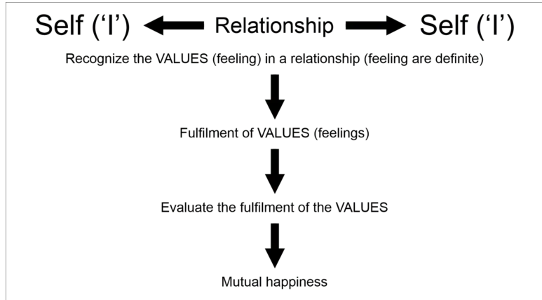

**What is the state today?**

We need to evaluate for ourselves whether we are able to ensure justice in relationships. Let us answer a few questions listed below:

* Do we want justice only on few occasions or every moment?
* Will the justice get ensured in the family or in courts of law?
* In how many relationships and on how many occasions, are we presently able to ensure justice?

These are quite relevant questions in our daily life. We tend to feel that we are being subjected to injustice. But, we seldom evaluate how just we are in our interactions. We see the partition of houses, family feuds, enmity in relations so often…. All these are the outcome of the injustice that starts in the relations at some point of time.

**Recognizing relationships with others based only on the body**

We are able to see ourselves as co-existence of the self (‘I’) and the body. As a result, we see ourselves as a body and we also see the other as a body and we subsequently reduce our relationships and the feelings in the relationship to the level of our body. We tend to assume that we have a relationship with our blood-related family members only. However, this wrong evaluation does not mean that the relationship with others is no more there.

When we see the relationship, we accept it. When we are not able to see it, we have a sense of opposition or lack of belongingness. The feelings in a relationship are the same with every human being, only that we are not aware of them. This is something we are going to explore in detail as we proceed further.

**Relationships largely based on the exchange of physical goods**

As a result of the mistaken assumptions of us being only the body and the relations with others being only at the level of the body, we have reduced our expectations in relationships to the mere fulfillment of physical facilities. We evaluate all our relationships in terms of material things like money, property, etc. In short, the purpose of the relationship has been reduced to physical and material needs and its exchange.

**Bringing up children in a harmonious family**

The most important function of a family can be said to be: ‘To develop into emotionally stable individuals, children need unconditional love, opportunities to develop self-confidence and appropriate guidance and discipline.’ Unlike basic physical needs of food, sleep, and shelter, a child’s mental and emotional needs may not be obvious. This makes it all the more essential for parents to acknowledge that a child’s mental health is as important as his physical health.

## Values in Human-Human Relationship

No individual or nation can live by holding itself apart from the community of others, and whenever such an attempt has been made under false ideas of greatness, policy, or holiness – the result has always been disastrous to the secluding one.

There are certain basic and important values in maintaining relationships. These values, we all know, are the backbone of health and happy family relations. The feelings, emotions, sentiments, and respect all are of real importance. These values lead to the elimination of friction and the establishment of total harmony in relationships on a long-term basis. Values that are important in any relationship are:

**1.Trust**  
**2.Respect**  
**3.Affection**  
**4.Care**  
**5. Guidance**

**6.Reverence**  
**7.Glory**  
**8.Gratitude**  
**9. Love**

The above-mentioned values are the core of all relations. One has to follow all to gain on the day-to-day problems. These values are intrinsic and available in every person. We need to find out in ourselves and implement. Without implementation, one can not think of strong family relation.

### Trust (Vishwas)

**“To be assured that each human being inherently wants oneself and the other to be happy and prosperous.”**

### Respect (Samman)

**“Respect means right evaluation, to be evaluated as I am.”**

### Affection (Sneh)

**“Affection is the feeling of being related to the other.”**

### Care (Mamta)

**“The feeling of care is the feeling to nurture and protect the body of our relative.”**

### Guidance (Vatsalya)

**“The feeling of ensuring right understanding and feelings in the other (my relative) is called guidance.”**

### Reverence (Shraddha)

**“The feeling of acceptance of excellence in the other is called reverence.”**

### Glory (Gaurav)

**“Glory is the feeling for someone who has made efforts for excellence.”**

### Gratitude (Kritagyata)

**“Gratitude is the feeling of acceptance for those who have made efforts for my excellence.”**

### Love (Prem)

**“Love is the emotion of strong affection and personal attachment. In other words, love is a feeling of warm personal attachment or deep affection, as for a parent, child, or friend.”**

## Trust (Vishwas)

Trust or Vishwas is the foundational value in a relationship.

***“To be assured that each human being inherently wants oneself and the other to be happy and prosperous.”***

Having faith in others and believing them. Mutual trust is a shared belief that we can depend on each other to achieve a common purpose. Trust is the expectation of people that they can rely on our word. It is built through integrity and consistency in relationships.

Trust-building is not the one-day work. This process of trust-building remain continues 24 hours and 365 days. One has to be honest in his approach otherwise trust will vanish. False commitment, false talks, and anything based on lies will erode the trust.

## Proposal about Trust

To understand trust, let us examine the following proposals:

* **I want to make myself happy**
* **I want to make the other happy**
* **The other wants to be happy**
* **The other wants to make me happy**

Ask yourself this question: “When do I feel afraid of somebody, and when do I feel assured?”

The answer is:

* **We feel assured of the other person when we are sure that the other wants to work for my happiness and prosperity.**
* **Whenever I feel the other will deny my happiness and/or prosperity, I am afraid of the person.**

When we are assured that the other is for my happiness and prosperity, I have trust in the other. When this is doubted, I lake the trust and it becomes the source of fear.

Let us explore further the following:

1. **Do I want to make myself happy?**
2. **Do I want to make the other happy?**
3. **Does the other want to make himself happy?**
4. **Does the other want to make me happy?**

We may give an easy ‘Yes’ to the first question. In the third question, we give a small thought and say ‘Yes’ again. In the second question, we hesitate to answer first, then we become choosy and tend to say that there are a few whom I want to make happy, and I am not concerned about the rest. Or, we may also say that I want to make some people unhappy, or, we may say that I want to make only those happy from whom I derive happiness and other such things. But we are not able to give an easy ‘Yes’ in the beginning.

When we examine, we find that there are two parts in this exploration:

1. Intention (wanting to – our natural acceptance)
2. Competence (being able to do)

The intention is what one aspires for (our natural acceptance), competence is the ability to fulfill the aspiration. 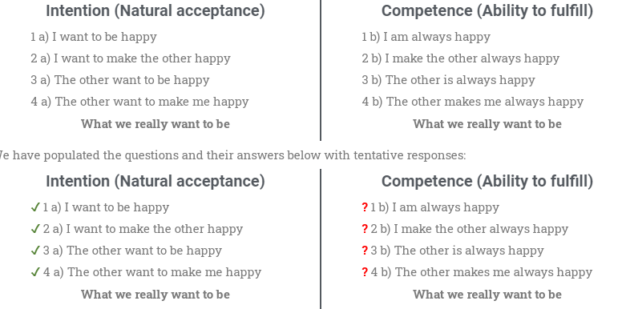

If we see this carefully we will realize that when we are judging ourself we are judging on the basis of our intention, whereas, when we are judging the other we are judging him on the basis of his competence. We are sure in point 2 a) that we want to make the other happy, but in point 4 a) we are not sure that the other wants to make us happy. We find that while we look at our intention, we are sure of it, we are not sure of the other’s intention. We are actually seeing their competence, and making a conclusion on their intention, we say “I wanted to do well, but I could not”. But for the other, we say “He did not want to do well”. “Wanting to”, is the intention, “could not”, is the lack of competence.

* We trust our own intention while we are not ready to trust the other’s intention. It is the same for the others as well. They would also have the same answers as we, to the table above. While the other trusts his/her own intentions, he/she does not trust mine. Hence, mistrust is born and we deny the relationship.
* We also see that we are not able to fulfill our intentions in terms of our competence at all times. It is the same for the other as well.
* We want to be related to the other, and we want the other to be related to us, irrespective of who this other is. If we have trust in the other, we are able to see the other as a relative and not as an adversary. We then become ready to become a help to the other. Intentions are always correct; it is only the competence that is lacking, which can be improved by the right understanding.

We may ask, **“How do we know what the other person’s intentions are?”**

**Ans:** I can judge myself properly, and find out about myself. If I am sure of the answers to 1 and 2 above, then 3 and 4 are just a reflection of 1 and 2. (Other person is a reflection of me)

* The mistake takes place because when I am looking at myself, I see my intention but, when I am looking at the other, I see his competence. As a result, I conclude about the intention of the other person based on his competence.
* Intention-wise, all of us want to make ourselves happy and the other person happy. Whereas competence-wise, we all are unable to do this.
* We also see that we are not able to fulfill our intentions in terms of our competence at all times. It is the same for the other as well.
* We want to be related to the other, and we want the other to be related to us, irrespective of who this other is. If we have trust in the other, we are able to see the other as a relative and not as an adversary. We then become ready to become a help to the other. Intentions are always correct; it is only the competence that is lacking, which can be improved by the right understanding.

We can see that just as our competence is lacking and we fail to always make the other happy, the other’s competence is also lacking, which is why they fail to always make us happy in relationship. But when the other fails, we very quickly doubt their ‘intention’, which is what causes the problems in relationship.

## Questions in mind

### How can I trust a stranger?

If we are able to see the relationship with the person at the level of ‘I’, we will see that the other person also is like us. The other person has natural acceptance for the same things as we have. He/she too wants to make himself/herself happy and wants to make us happy at the level of his intention, just as we. But he/she is unaware of this fact, just as we has been. Hence, he/she may be interacting with us based on our competence. The way out is to relate to the other person, to be able to see that at the level of natural acceptance, we are the same. We can then interact with the person based on their competence, and also help them improve their competence.

### How can I trust someone who has bad intentions?

In this statement, the word ‘intentions’ is used in a different sense. When we normally use the word ‘intention’ today, we are only considering the ‘competence’ (rather lack of it), and not the real intention. For example someone may be plotting to rob a house. We may say ‘he wants to rob my house’. Actually, the person has assumed that robbing our house will make him fulfill his physical needs and be prosperous, at the level of his desires, thoughts, and expectations (selections). Because:

* He has not paid attention to his own natural acceptance at all (no one, even in education, pointed this out to him)
* Due to the unfavorable circumstances that he has grown up in, or lives in, he has assumed that robbing is right or the only way. So he goes ahead and does it.

But this is still at the level of his desires, thoughts, and selection and hence his competence (or lack of it), and not his intention or at the level of his natural acceptance. When we say that the robber ‘wants’ to rob our house, he is actually “desiring, thinking and selecting this in absence of realization and understanding”.

### I know someone’s character is not good. How can I trust someone like that?

We look at someone’s behavior, what one thinks, what one does, and end up concluding on the other’s ‘character’. Whereas this is actually the lack of competence, it is at the level of desires, thoughts, and selection in ‘I’ keeps changing. Hence, people are unpredictable and we end up doubting their character. However, if we start looking at the level of the person’s natural acceptance, we find that we are all the same. So, when a person behaves badly, it is not that he/she truly wants to have a bad character; rather, he/she is just operating at the level of assumptions and beliefs – which is the competence or rather, lack of it. Character at the level of one’s competence is different from intention/natural acceptance. The former is unstable and unpredictable, the latter is definite. We have to start seeing the latter, since the former is not acceptable to us, and only leads to problems.

### If I trust everyone, wouldn’t people take undue advantage of me?

On the contrary, it gives us inner strength and we become far more effective in interacting with and “dealing with different people”. This is simply because, we already are sitting with the knowledge of what the person truly wants, truly intends, even though the person may not know this himself/herself! Hence, our ability to interact with people becomes far more effective and in the process, we don’t get hurt, we don’t get disturbed, we end up becoming an aid to the other. In other words, becoming aware, having the right understanding, living with the assurance in a relationship does not mean becoming “stupid”! It only makes us, more competent. Further, what is being said here is that we have trust on the intention of everyone, but, when it comes to making a program with someone, I evaluate my competence, I evaluate his competence, and make the program accordingly. This makes me more effective.

### This person can never be trusted. Be careful of that person.

This only means that the person we are talking about is someone that is under wrong assumptions, all the time! It means their competence is really lacking. The other is not aware of one’s own natural acceptance at all and hence has assumed things that only make one unhappy, but also to see the truth, to be able to access their own natural acceptance.

### Never trust anyone blindly.

To be blind, means not to have the right understanding. It means we are aware of our own natural acceptance. It means we are living solely on the basis of our imagination, or our elections. Not to be blind means to be aware, to know the truth, to have the right understanding. For this, we have to start this dialogue within ourselves, between what we are, and what we really want to be.

***So, you can trust anyone (for the intention part)! But don’t assume that his/her desires, thoughts, and expectations are going to be right (he/she may lack competence)!***

It is important to be able to differentiate between the intention (wanting to) and the competence (the ability to do so). The intention of the other is always to make us happy, just like we always have the intention of wanting the happiness of the other. But ours’, as well as the other’s competence is lacking, for which we have to accept responsibility to improve and work towards having the right understanding for this improvement.

In all our relationships, trust is the foundation. A relationship without trust result in opposition, the relationship itself gets shaken up. Lack of trust is what ultimately leads to an extreme situation like war.

**Trust is thus called the foundation value.**

## Respect (Samman)

Respect means individuality. The sense of individuality is prime object. This is the first basic step towards respect (samman). Once we realized that we are individual then only we can see ourself different from others. In other words:

***“Respect means right evaluation, to be evaluated as I am.”***

Usually, we make mistakes in our evaluation in the following three ways.

### 1. Over evaluation – to evaluate more than what it is.

If you are wrongly flattered you feel uncomfortable. Eg. You are sitting at home and there are guests around. Your father says ‘My son/daughter is the greatest scholar in India!’ Check for yourself; do you feel comfortable, or do you feel uncomfortable?

### 2. Under evaluation – to evaluate less than what it is.

If you are condemned, you feel uncomfortable. Eg. You are still at home, but this time your father says ‘My son/daughter is good for nothing. He must be the laziest person in all of India!’ You obviously feel uncomfortable, you don’t find this acceptable.

### 3. Otherwise evaluation – to evaluate otherwise than what it is.

If you are evaluated as something else, you feel uncomfortable. Eg. You are at home and there are guests around and your father says ‘You donkey! Can’t you even understand this much?’ You feel offended by this. This is evaluating you otherwise, as you are a human being and not something else.

We can see that any kind of over, under, or otherwise evaluation makes us uncomfortable, we find it unacceptable. We feel ‘disrespected’. We say we have been disrespected when we are wrongly evaluated.

Thus, respect means to rightly evaluate. Can you think of the number of instances when you feel you have wrongly evaluated, and the number of times you may have done the same to others? You would be surprised to find, this happens very often, and we are insensitive about this aspect in relationship. Even though it is the cause of many problems for us in relationship, we ignore the point about respect. We also have many different notions about respect that we currently hold as individuals and as a society. For example, saluting someone is called respecting someone today, even fire guns in the air after people are dead, as a mark of ‘respect’, we put red bulbs on our cars for respect, we build big houses in the thirst for respect, we take care of our clothing, we dress up, we have different hair cuts, we buy fancy cell phones, we boast about the bike we have, a whole lot of things are going on in the world in search for respect.

Respect denotes both a positive feeling of esteem for a person or other entity (such as a nation or a religion) and also specific actions and conduct representative of that esteem. Respect can be a specific feeling of regard for the actual qualities of the one respected (e.g., “I have great respect for her judgment”). It can also be conducted in accord with a specific ethic of respect. Rude conduct is usually considered to indicate a lack of respect, disrespect, whereas actions that honor somebody or something indicate respect. Respect should not be confused with tolerance, since tolerance doesn’t necessarily imply any positive feeling, and is incompatible with contempt, which is the opposite of respect.

**On a practical level, it seems to include taking someone’s feelings, needs, thoughts, ideas, wishes, and preferences into consideration.** We might also say it means taking all of these seriously and giving them worth and value. In fact, giving someone respect seems similar to valuing them and their thoughts, feelings, etc. It also seems to include acknowledging them, listening to them, being truthful with them, and accepting their individuality and idiosyncrasies.

**Respect can be shown through behavior and it can also be felt.** We can act in ways that are considered respectful, yet we can also feel respect for someone and feel respected by someone. Because it is possible to act in ways that do not reflect how we really feel, the feeling of respect is more important than the behavior without the feeling. When the feeling is there, the behavior will naturally follow.

## Basis for respect - Proposals

When it comes to respect a human being, will you respect a human being on the basis of ‘I’ or body? If you respect a human being on the basis of ‘I’, the following things are true for every human being:

1. I want happiness and prosperity.
   * The other too wants to be continuously happy and prosperous!
2. To be happy, I need to understand and live in harmony at all four levels of my living.
   * The other also needs to understand and live in harmony at all four levels of his/ her living!
3. The activities in me (‘I’) are continuous, we can check this for our desires, thoughts, and expectations.
   * It is the same for the other ‘I’ as well. The activities are continuous there as well, and the other too has continuous desires, thoughts, and expectations!

When we see the above, what can we conclude? The other person also feels quite like me! There are so many similarities! Let us put down these similarities, in order:

1. We both want to have continuous happiness and prosperity.
   * **Our basic aspiration is the same.**
2. We both need to have the right understanding, which is to understand and live in harmony at all four levels of our living.
   * **Our program of action is the same.**
3. The activities and powers of the self are continuous and the same in both of us – at the level of ‘I’.
   * **Our potential is the same.**

Based on these three evaluations we can conclude that

**The other is similar to me.**

When we are able to see that the other is similar to me, we are able to recognize the feeling of respect in the relationship. If not, we either hold ourselves, more or less than the other and this only leads to differentiation.

## Assumed basis for respect today

Our basis for respect today is largely quite contrary to our discussion above. Instead of respect being a basis of similarity or one of right evaluation, we have made it into something on the basis of which we differentiate i.e. by respecting you, mean you are doing something special because you are special or have something special or are in some special position. Thus, all of us are running around seeking respect from one another by trying to become something special.

Today, we are differentiating in the name of respect. We either differentiate people on the basis of their body, on the basis of their wealth and possessions, or on the basis of their beliefs. There is no notion of respect in terms of right evaluation. Thus, there is no real feeling of relationship, only one of differentiation.

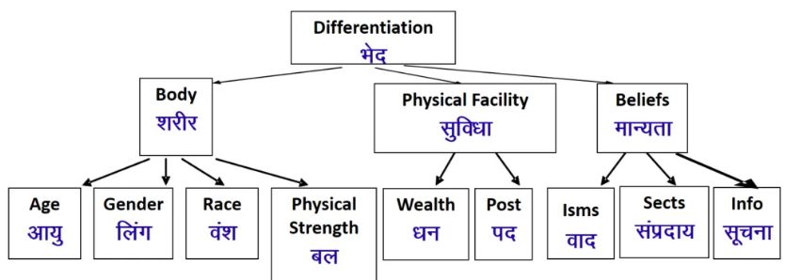

There are different ways we differentiate between people today! Let us look at them in detail one by one:

### On the basis of body

#### Sex/gender

We have such notions as, respect males more than females, or even the other way round in some societies. We ignore the fact that being male or female is an attribute of the body and not an attribute at the level of ‘I’. In many countries, people even prefer a male child to a female child, and in some other societies, the other way round.

#### Race

If the person is of the same race as oneself, then we treat them differently. For example, we differentiate on the basis of skin colour – white, brown, black etc. or on the basis of whether the person is of the Aryan race, Mongolian race, etc., or on the basis of caste, taking some caste to be high, the other to be low. Again here, we don’t do the evaluation on the basis of ‘I’, but on the basis of the body- the color of the skin or the race or the caste of the body, i.e. by the features, long noses, short noses, height, etc.

#### Age

We have notions such as ‘one must respect elders’. What about youngsters? Should we insult them? Should we not respect them as well? Here, we see that we are again evaluating at the level of the body – age is related to the body, and not to ‘I’.

#### Physical strength

If someone is stronger, we again treat him/her differently. This is again at the level of the body. In fact, we think that we are respecting the other while it is fear; the fear that if we do not treat them like this, we will be harmed.

### On the basis of physical facilities

#### Wealth

We differentiate people because some have more wealth than others. What we term as a “rich person” gets idolized. We don’t even bother to find out whether such people are feeling prosperous, or if they just have wealth? Are they happy, or just have wealth? – This is an evaluation on the basis of physical facilities. This way, we are over-evaluating physical facilities first, which are just meant to fulfill the needs of the body, and then on this basis, we are wrongly identifying our relationship.

#### Post

This is a very common phenomenon. We try to respect on the basis of a person’s position. Is this post directly related to the right understanding and feelings in the self? – We seldom verify. The post is wrongly evaluated as the mark of a person’s excellence and differentiation sets in. The post is considered important either on the basis that it gives more physical facilities or on the basis that certain positions are assumed to be important! In our education, we are trained directly or indirectly to earn posts for us to fetch respect.

### On the basis of beliefs

#### Isms

**‘Ism’ means any belief in terms of a ‘thought system that we have, or that we have adopted.** There are also many modern ‘isms’ such as capitalism, socialism, communism, etc. the people following these sets of beliefs are called capitalists, socialists, communists, and so on. We only have to look into this today, and we shall find countless such belief systems … and the people that have adopted them or are following them have been exposed to them since childhood. Believing theirs to be the right belief. However, all beliefs, as we have seen are at the level of desires, thoughts, and expectations (selections) in ‘I’ (activities 3, 4, 5). As we have already seen, there is no definiteness at this level, and hence, this becomes a cause for differentiation.

#### Sects

People of one sect only consider those with a similar belief system to be their ‘own’ and worthy of respect. Following a particular tradition, or what we call as religion, becomes the basis of respect and disrespect in relationship.

#### Info

Regarding the information – if you have one set of information, say, as an engineer, you will be respecting engineers and not, for example, doctors and vice-versa.

## The problems due to Differentiation

#### Differentiation based on sex/gender

There are many movements in the world around this. For example, we have the issue of women’s rights, and women protesting and demanding equality in education, in jobs, and in peoples’ representation. The growing feminine movement is an example of this. As discussed earlier, this problem is acute in some areas, with people not wanting a girl child and preferring male children instead, while in some other societies, it could be the other way round. At the level of the individual, people are insecure and afraid of one another based on their gender.

#### Differentiation based on race

There are many movements and protect against racial discrimination, and demand for equality. We hear of racial attacks, which are basically to do with this issue of respect. The movements against cast discrimination have been growing in India for over decades. Such discrimination leads to people living in fear of such racism, racist attacks, casteism, and discrimination.

#### Differentiation based on age

We hear of protests and movements demanding equal rights for children on the one hand and for rights for elderly people on the other. The problem of the generation gap is talked about quite often. One generation talks about being ignored by the other generation, and this has become the source of tension in many families.

#### Differentiation based on wealth

This is an area that is increasingly becoming a very big area of differentiation and is leading to all kinds of large-scale problems. We are all aware of the whole debate around rich countries and poor countries. Not understanding the need for physical facilities, and working for wealth to fetch respect has led to class struggle and movements to do away with class differentiation. If the need for physical facilities is understood properly, we do not identify it with happiness. Otherwise, we find a large problem at the level of individuals, with many people suffering from a lack of self-esteem and some even committing suicide when they feel they cannot accumulate enough wealth so as to get the respect that is due to them.

#### Differentiation based on post

We see protests against high-handed government officials because people feel they are being taken advantage of. This is due to the tremendous differentiation we make on the basis of position. At the level of the individual, it also leads to depression, etc. since if someone does not get or qualify for a post, they end up feeling that they will not get respect in society.

#### Differentiation based on Isms

We are all quite aware of this differentiation on the basis of different thought systems. Communism for example always seems to be at war with capitalism and feudalism. We hear of fights, turmoil, terrorism, and war, most of them to do with these Isms. We even hear of people converting from one Ism to another in order to be able to get more respect.

#### Differentiation based on sects

We are all well aware of this. We have ended up making countless religions and sects and each sect has its own movement to ensure that there is no discrimination against people of their belief. There are demands for special provisions in jobs and in education based on religions and sects. Some of these protests and clashes between people of different beliefs even turn violent.

## What is the Way Out

To move beyond differentiation, **we have to begin to understand the human being as the co-existence of self (‘I’) and the body and then base our evaluation on the basis of the self (‘I’)**, where we will find that we are similar to the other (in terms of our natural acceptance program of action and potential). This becomes the basis of the feeling of respect in our relationships with other human beings. We differ from the other only in terms of competence, and there we either learn from the other or take responsibility for helping the other to improve their competency. So, we need to start this process of self-exploration and begin to see that human being is actually co-existence of self (‘I’) and body, and the two have different needs.

It is important to remember that respect (or right evaluation) is a value (feeling) in a relationship. Once, we have this feeling of respect out of the understanding of relationship, it is the state of harmony between one human and the other.

The difference between me and the other can only be at the level of understanding (not information). It is important to differentiate between ‘understanding’ and ‘information’. This difference manifests as a meaningful responsibility and is not a criterion to hold superiority or inferiority.

1. **If the other has a better understanding than me**
   * **I want to understand from the other. This is my responsibility.**
2. **If the other has less understanding than me**
   * **I live with a sense of responsibility with the other, ensuring mutual fulfillment and I accept the responsibility to improve the understanding of the other. This again is my responsibility since I am related to the other. (Would I not work on developing the understanding of my relative?)**

**Affection (Sneh)**

***“Affection is the feeling of being related to the other.”***

Affection comes when I recognize that we both want to make each other happy and both of us are similar. Then for the first time, I feel that I am related to the other that the other is a relative of mine. This feeling is called affection.

The feeling of affection comes only if trust and respect are already ensured. Without trust and respect, you feel the other is trying to make you unhappy, does not wish well for you and hence you can never feel affection for him/her. You always see the other as being in opposition. And that is why today in the family, you find that people have been living together for years and years and still don’t feel related to each other, because that basic trust and respect are missing.

**Care (Mamta)**

***“The feeling of care is the feeling to nurture and protect the body of our relative.”***

Or in other words, a state of mind in which one is troubled; worry, anxiety or concern is called care. Care is level of active concern, or lack of negligence, towards avoidance of possible dangers, mistakes, pitfalls, and risks, demanded of a party as a duty or legal obligation.

We understand a human being as a coexistence of the self (‘I’) and the body, and the body is an instrument of ‘I’. Based on this understanding, we take the responsibility of nurturing and protecting the body of our relatives.

**Guidance (Vatsalya)**

***“The feeling of ensuring right understanding and feelings in the other (my relative) is called guidance.”***

We understand the need of self (‘I’) for the right understanding and feelings. We also understand that the other is similar to me in his/her faculty of natural acceptance, the desire of wanting continuous happiness, and the program of living in harmony at all four levels. The other is also similar to me in the potential of desire, thoughts, and expectation.

**Reverence (Shraddha)**

***“The feeling of acceptance of excellence in the other is called reverence.”***

We understand that we aspire for continuous happiness and to realize it, we have to understand harmony at all the levels of our living and live accordingly. When we see that the other has achieved this excellence- which means to understand and to live in harmony at all the levels of living ensuring continuity of happiness, we have a feeling of reverence for him/her. This feeling of accepting the excellence in the other is called reverence.

**Glory (Gaurav)**

Each one of us wants to live with continuous happiness and prosperity. Each one of us has the similar faculty of natural acceptance, has the same goal and program and we have the same potential to realize this.

***“Glory is the feeling for someone who has made efforts for excellence.”***

We find that there have been people in history, or even around us, who are investing their time, energy, and their belongings to achieve excellence (to understand and to live in harmony at all levels of living ensuring continuity of happiness), to make others excellent. This gives us a feeling of glory for them.

**Gratitude (Kritagyata)**

We understand that each one has the goal of continuous happiness and prosperity. Each one of us has to work towards increasing our competence to realize our intention and in this process, we are helped and guided by others that have the right understanding. When we understand this and begin to recognize the feeling in ourselves, we feel gratitude in our relationship.

***“Gratitude is the feeling of acceptance for those who have made efforts for my excellence.”***

Today, we find that generally what we call ‘gratitude’ is a feeling coming out of assistance at the level of physical facilities. This feeling is short-lived since the happiness we get from the right understanding is permanent.

Gratitude is an emotion that occurs after people receive help, depending on how they interpret the situation. Specifically, gratitude is experienced if people perceive the help they receive as:

* Valuable to them
* Costly to their benefactor
* Given by the benefactor with benevolent intentions (rather than ulterior motives)

**Love (Prem)**

***“Love is the emotion of strong affection and personal attachment. In other words, love is a feeling of warm personal attachment or deep affection, as for a parent, child, or friend.”***

In a philosophical context, love is a virtue representing all of the human kindness, compassion, and affection. In a religious context, love is not just a virtue, but the basis for all beings (“God is love”), and the foundation for all divine law (Golden Rule).

The word love can refer to a variety of different feelings, states, and attitudes, ranging from generic pleasure (“I loved that meal”) to intense interpersonal attraction (“I love my wife”). “Love” can also refer specifically to the passionate desire and intimacy of romantic love, to the sexual love of eros (cf. Greek words for love), to the emotional closeness of familial love, or to the platonic love that defines friendship, to the profound oneness or devotion of religious love. This diversity of uses and meanings, combined with the complexity of the feelings involved, makes love unusually difficult to consistently define, even compared to other emotional states.

This feeling or value is also called the complete value since this is the feeling of relatedness to all human beings. It starts with identifying that one is related to the other human being (the feeling of affection) and it slowly expands to the feeling of being related to all human beings. The feeling of love leads to an undivided society, it starts from a family and slowly expands to the world family in the form of love.

**Harmony from Family to World Family: Undivided Society**

Justice (recognition of feelings in a relationship, its fulfillment, evaluation leading to mutual happiness) starts from the family and slowly expands to the world family. In family, we learn to recognize relationships, definite feelings, or values and learn how to fulfill them. If we do not understand the values in relationships, we are governed by our petty prejudices and conditionings. This leads to a fragmented society while our natural acceptance is for an undivided society and universal human order.

***Undivided society (Akhanda Samaja) – feeling of being related to every human being.***

The feeling of being related to every human being leads to our participation in an undivided society (Akhanda Samaja). With the understanding of values in human relationships, we are able to recognize the connectedness with every individual correctly and fulfill it. When we understand the value in relationship with other units in nature too, we are able to recognize our connectedness with them and fulfill it. This enables us to participate in the universal human order (Sarvabhaum Vyavastha).

## Difference between various terms

### 1. Intension and Competence

#### Intention

1. Intention is what one aspires for  
   (our natural acceptance)
2. It is about our natural acceptance
3. What you want to be
4. What you really want to be

#### Competence

1. Competence is the ability to fulfill the aspiration
2. It is about our ability
3. What you are ∑DTE
4. What you are

I make effort to accentuate the difference, to manipulate, exploit the other

### 2. Attention and Respect

#### Attention

1. Attention is **earned by accumulating only physical objects or doing lot of surplus activities l**ike climbing mountains for the sake of fame, putting all kind of clothes, letting their hair or nails grow long earning a lot of money working very hard to be on the magazine cover, the list is simply endless.
2. It makes us uncomfortable; it creates a feeling of opposition

#### Respect

1. Respect is right evaluation.
2. Respect for others is generated by the right evaluation and understanding which leads to fulfillment in relationships. This further creates a sense of respect among people.
3. If we see our relationship with others, we shall anyway respect others. Other one don’t have to do something special to earn respect from us. **The fact that we are human is enough for us to respect others.**
4. This makes us and other happy. It makes both of us comfortable; it puts both of us at ease.

### 3. Differentiation and Respect

#### Differentiation

1. Differentiation is lack of understanding of respect.
2. This differentiation can take the form of:
   * Gender bias
   * Generation gap
   * Caste struggle
   * Power play and domination
   * Communal violence
   * Clash of race, religion, etc.
   * Class struggle
3. This leads to the escalation in the problems of society which further lowers the respect shown to others in society.
4. I evaluate on the basis of body, physical facilities, or belief (preconditioning). I compare, compete, differentiate…

**I am different from the other.**

We are competitors.

I make effort to accentuate the difference, to manipulate, exploit the other

#### Respect

1. Respect is right evaluation.
2. Respect for others is generated by the right evaluation and understanding which leads to fulfillment in relationships.
3. This further creates a sense of respect among people.
4. I evaluate on the basis of our purpose, program and potential.
   * Our purpose (Natural Acceptance) is same.
   * Our program is same.
   * Our potential is same.

**The other is similar to me.**

We are complementary to each other.

If the other has more understanding than me  
– I am committed to understand from the other  
If I have more understanding  
– I live with responsibility with the other.  
– I am committed to facilitate understanding in the other (once the other is assured in relationship, and not before that)

### 4. Self respect and Abhiman

#### Self Respect

1. Self-respect is the virtue of oneness.
2. The thought process in self-respect is related to the duty towards himself without selfishness.
3. To undermine the self-respect of other is a sin. It is the highest form of self-respect to admit our errors and mistakes and make amends for them.

#### Abhiman

1. Abhiman is the result of gaining supremacy in an area with ego.
2. To make a mistake is only an error in judgment but to adhere to it when it is discovered shows infirmity of character.

### 5. Respect and Ego

#### Respect

1. Respect is a positive feeling.
2. It is progressive. It allows individual to see beyond self towards the betterment of the entire society.
3. Respect doesn’t mean bringing down the higher, but be raising the lower up to the level of the higher.

#### Ego

1. Ego is a negative feeling.
2. It stops the progress because it narrows your vision and natural acceptance.
3. In ego every person try to bring down the higher by any mean. This nature starts the process of self-destruction. One cannot learn new things, but keep on thinking the evil methods to bring down the progressive person.

### 6. Excellence and Competition

#### Excellence

1. The other is like me.
   * We are complementary.
2. Feeling are based on right understanding (definite, unchanging)
3. Unconditional relationship
4. Nurtures others
5. Helps the other to come to his level
6. Is prosperous – Rightly utilizes, shares, nurtures
7. Absolute (definite completion point)

#### Competition

1. Not other – only me.
   * I am different/more than the other.
2. Feelings are based on preconditioning (indefinite, keeps changing)
3. Conditional relationship
4. May nurture or exploit others
5. Stops the other to come to his level – effort to accentuate the difference, to dominate, manipulate, exploit
6. Is deprived – Hoards, accumulates, exploits
7. Relative (no definite completion point)

### 7. Affection and Competition

#### Affection

1. Affection means**a feeling of togetherness**.
2. When there is affection, I help the other to grow

#### Competition

1. Competition means **the act of competing, rivalry for supremacy**, a prize, etc.
2. It is a rivalry between two or more persons or groups for an object desired in common, usually resulting in a victor and a loser.
3. When I miss the feeling of affection, I try to beat the other, act as an opponent.

### 8. Response and Reaction

#### Response

1. You decide your feeling on your own right.
2. It is based on the right understanding.  
   You always have the right feeling. It is definite and unconditional.  
   **The behavior of the other is only an indicator of the state of the other.**With that input, you decide your behavior to ensure mutual happiness.
3. **You decide your own behavior.**
   * **You are self-organized.**
4. **Your conduct is definite.**

#### Reaction

1. You decide your feeling based on the behavior of the other.
2. **It depends on whether you like or dislike the behavior of the other.**
   * If the other behaves properly, you have the right feeling and may behave properly.
   * If the other misbehaves, you have a wrong feeling and you may also misbehave.
3. **Your “remote control” is with the others.**
   * **You are enslaved.**
4. **Your conduct is indefinite.**

### 9. Love and Infatuation

#### Love

1. Happiness = Right understanding & right feeling in the self
2. Love = feeling in the self
3. Based on relating to the other-self unconditionally
4. Continuity is possible

#### Infatuation

1. Happiness = sensation (through the body) & feeling from other
2. Love = sensation
3. Infatuation, Attraction, Liking, Lust, Vasna, based on getting sensation/feeling from the other
4. Continuity is not possible

## Chapter 2: Harmony in the Society – from Family to World Family Order

**Society**

***“Society or human society is the set of relations among people, including their social status and roles.”***

By extension, society denotes the people of a region or country, sometimes even the world, taken as a whole. Used in the sense of an association, a society is a body of individuals outlined by the bounds of functional interdependence, possibly comprising characteristics such as national or cultural identity, social solidarity, language, or hierarchical organization. Human societies are characterized by patterns of relationships between individuals sharing a distinctive culture and institutions. Like other communities or groups, a society allows its members to achieve needs or wishes they could not fulfill alone.

The word society may also refer to an organized voluntary association of people for religious, benevolent, cultural, scientific, political, patriotic, or other purposes. Today the term society is currently used to cover both a number of political and scientific connotations as well as a variety of associations.

**Extended relationship from Family to Society**

As we begin to understand our relationship in the family and live harmoniously in these relationships, we become aware of our relatedness to all human beings. Family is the first place to understand our relationships, recognizing the feelings in these relationships live according to these feelings and attain mutual happiness. Our natural acceptance is to feel related to everyone. We can easily explore this within ourselves. We find that in reality, we do not only want ourselves to be happy but also want to make others happy.

Our competence might be limited at the moment and we might feel we are unable to do so but we spontaneously accept that we wish for their happiness as well, along with ours; this is our intention. We expect the same from the other. We feel relaxed when we are with people who feel related to us and we enjoy a feeling of assurance and trust when we live in this social web.

Harmony in the family is the building block for harmony in society. Harmony in society leads to an undivided society when we feel related to each and every human being. Our natural acceptance, however, is for relatedness with all and we can very naturally expand into the world family. This is the basis of an undivided society (Akhand Samaj), a feeling of relatedness with all. As we begin to understand and become aware of the harmony at this level in our living, we begin to see our responsibility and participation in it.

**Identification of the comprehensive human goal**

In order to facilitate the fulfillment of the basic aspirations of all human beings in the society, the following comprehensive human goal needs to be understood.

1. 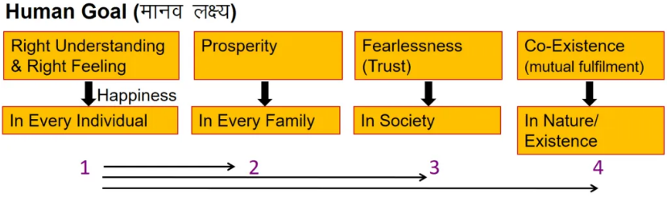Right understanding is necessary for human beings, for all human beings. When one does not have the right understanding, one remains disturbed and also acts in a manner so as to create disharmony with other human beings as well as with the rest of nature.
2. Prosperity is needed in every family. Prosperity in the family means that the family is able to identify its needs and is able to produce/ achieve more than its requirements.
3. Trust in society means every member of society feels related to everyone else and therefore there is trust and fearlessness.
4. Co-existence in nature means there is a relationship and complementarity among all the entities in nature including human beings.

This is the **comprehensive human goal**.

With a little exploration, we find that all four are required for human society. We are not satisfied with anything less than this. This is the basic minimum requirement to ensure sustainable happiness and prosperity. We can’t cut down any of them. This is the minimum level that each one of us wants, and also the maximum we can think of. We can’t think of anything more than this. This is the target for each one of us, the whole human race, and the human tradition. The moment we leave anyone of them out, there will be a loss of continuity, and the goal cannot be achieved.

**Samadhan**

We can solve society’s problems when we see beyond the contradictions of life. When we live in higher consciousness, we obtain the higher knowledge that sees the higher harmonies which enable the resolution of every problem.

**Samridhi (Prosperity)**

Prosperity is the state of flourishing, thriving, success, or good fortune. Prosperity often encompasses wealth but also includes other factors which are independent of wealth to varying degrees, such as happiness and health.

**Abhay**

Man is eager to live and afraid to die. Most problems owe themselves to this fact. The fear of death might be reckoned as a prime fear but the most primeval and basic fear is that of expectation being defeated, or more specifically, that of losing what one delusively thinks one owns (the delusion “this is mine”). Fear of losing what one is attached to (the family, for example) gives birth to the fear of death and therefore the former is the most basic fear because one is attached to the body and is afraid to lose it. Fear resides within and not outside us. External fear is mere fiction. If we succeed in cultivating fearlessness no incident, no external circumstances can strike fear in us.

Abhay is not associated with Bhay and Nirbhay, at all. Abhaya means fearlessness; it is a permanent state where there is no question of ever experiencing any fear. A person with Abhay is continuously aware of his own reality; for him to become subject to fear would be impossible. We should not consider this quality of Abhay as just the absence of fear.

Fear is only a delusion created by the mind; lack of fear is also a delusion created by the mind. Mistaking one thing for another leads to fear; recognizing the mistake and rectifying it, leads to the removal of fear. These two, Bhaya and Nirbhaya, are associated with fear and freedom from fear.

**Sah-astitva (Co-existence)**

The world is full of Diversity – there are different nations, cultures, religions, communities, languages, and beliefs. The beauty of existence can only be maximized if everything in this world is in harmony. Peaceful, symbiotic co-existence is the key to harmony in the world. For peaceful co-existence to occur in a diverse society the following must happen:

1. People must recognize that traditional interpretations of peaceful co-existence are outdated.
2. Governments and individuals must recognize that society needn’t be homogeneous or institutionalized to serve an important purpose for people.
3. Members of varying cultures, countries, and faiths must learn to respect the traditions, beliefs, and boundaries of one another.
4. Religion and politics must be separate.
5. People must agree to disagree regarding certain moral values and beliefs and come to recognize that others can be different from them and yet be equally capable in their own unique manner.

The above-mentioned goal is not only comprehensive but also universal i.e. equally applicable to all human beings and for all times. It includes all our aspirations and this is the goal for each one of us. **Thus it becomes the goal of human society or the basic need of human civilization.**

Now how are the four related? We will find the following when we look for the relation in the above:

1. The harmony in society begins with the individual. We need to ensure the right understanding in the individual as the foundation of harmony in the society.
2. With the right understanding, the need for physical facilities in the family can be ascertained. By assessing our needs correctly and by producing more than required the family can be prosperous.
3. Assurance of right understanding in the individuals and prosperity in the families, understanding of human relationships leads to harmony and trust (fearlessness) in the society. When every individual is able to live harmoniously in a relationship, and the needs of all the families are ensured, fearlessness (mutual trust) in society will naturally follow.
4. When human beings with the right understanding interact with nature, it will be in consonance with the co-existence and will be mutually enriching.

We may also understand it in the following sequence.

**1. Right understanding ⇒ 2. Prosperity ⇒ 3. Fearlessness (trust) ⇒ 4. Co-existence**

## Programs needed to achieve the comprehensive human goal: the five dimensions of human endeavor

The five dimensions of human endeavour are:

1. Education – Right Living (Siksha – Sanskar)
2. Health – Self Regulation (Swasthya – Sanyam)
3. Justice – Preservation (Nyay – Suraksha)
4. Production – Work (Utpadan – Kriya)
5. Exchange – Storage (Vinimaya – Kosh)

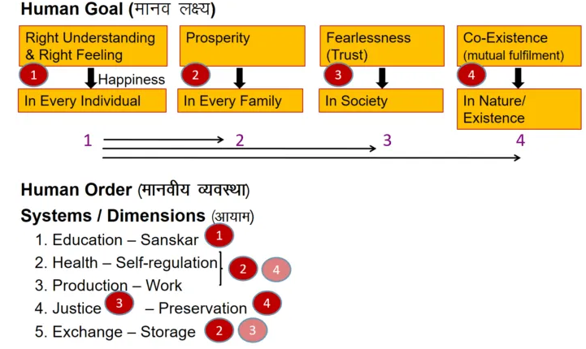

### 1. Education – Right Living (Siksha – Sanskar)

The content of education is the understanding of harmony at all the four levels of our existence – from myself to the entire existence.

Right living or Sanskar refers to the ability to live in harmony at all four levels of living. Thus,

***Education: to understand hormony at all four levels of living.******Right living: commitment and preparedness to live in harmony at all four levels of living.***

We have to ensure the availability and continuity of education – right living in our society. This dimension of society works to ensure ‘right understanding’ and ‘right feelings’.

### 2. Health – Self Regulation (Swasthya – Sanyam)

Sanyam refers to a feeling of responsibility for nurturing, protecting, and rightly utilizing the body.

When the body is fit to act according to the needs of the self (‘I’), and, there is harmony among the parts of the body, it is referred to as health or Swasthya.

***Sanyam (or self–regulation) is the basis of Swasthya.***

### 3. Justice – Preservation (Nyay – Suraksha)

Justice (Nyay) refers to harmony in the relationship between human beings, while preservation (Suraksha) refers to harmony in the relationship between human beings and the rest of nature.

***Justice: ‘Human-Human relation’ – its recognition, fulfillment, evaluation – leading to mutual Happiness.******Preservation: ‘Human-Rest of nature relation’ – its recognition, fulfillment, evaluation – leading to mutual Prosperity. – Enrichment, Protection, Right Utilization of nature.***

#### Justice

We say there is justice in a relationship when there is mutual fulfillment i.e. both individuals are satisfied: which means the values are rightly recognized, fulfilled, rightly evaluated, and mutual happiness is ensured. Mutual happiness is the goal in relationship and each one of us has a responsibility in ensuring a continuity of justice or nyaya in our society.

#### Preservation

Besides human-human relationships, we also have to work to ensure that our relationship with the rest of nature is mutually enriching for humanity as well as for nature. This dimension of our society works to ensure ‘Suraksha’. This involves ensuring the following three aspects –

1. Enrichment (I cultivate wheat; this enriches wheat as the quantity grows)
2. Protection (I protect it so that it is fit to eat)
3. Right utilization (I use it for nurturing the body and do not let it get wasted).

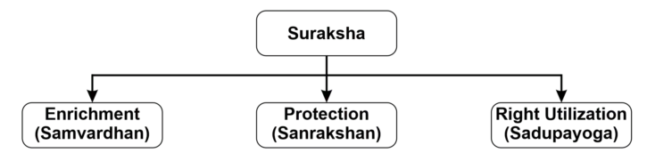

### 4. Production – Work (Utpadan – Karya)

Work refers to the physical efforts made by humans on the rest of nature, while production refers to the output / physical product that is obtained through these efforts.

#### What to produce?

The decision of what to produce depends on the right identification of needs. For this, we have to identify the physical needs of the body, i.e. what is needed for the nourishment, protection, and right utilization of the body. When we look into this, we can see that there is a need for food, clothing, shelter, and various kinds of instruments (ex: means of transport, communication, remote viewing of images, etc.) for the right utilization of the body.

#### How to produce?

When we come to the question of how to produce, we are referring to the technology or systems we use for production. On the understanding of harmony at all the levels of our living, it becomes evident that there is an inherent balance, a harmony in nature. So, it is only natural that any production system we design or implement is within the framework that is present in nature, i.e. it does not violate the framework/harmony in nature. When we look at the way in which nature is organized, the following becomes apparent:

1. The systems in nature are cyclic i.e. they are not open-ended.
2. The systems in nature are mutually fulfilling or mutually enriching.

Thus the way to produce is: Through the cyclical (Avartansheel) process, in harmony with nature.

1. It has to be cyclic
2. It has to ensure that every unit is enriched

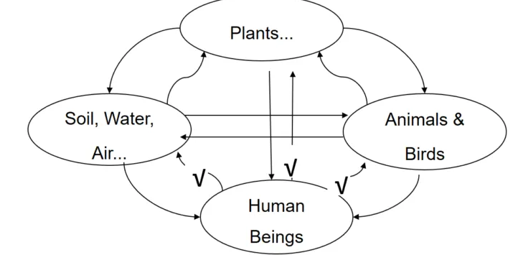

In nature, there are four different kinds of entities. One kind of entity includes materials such as air, water, soil, metals, and non-metals, etc. The other kind has plants, herbs, etc. The other kind of the third kind has animals and birds, and the fourth kind includes human beings. When you look at their interrelationship, you find that the materials, plants, and animals are enriching for the other entities including human beings.

If only we understand the process in nature, we can design our production systems through the application of science and technology in such a way that this mutual fulfillment is better ensured, rather than disturbing it.

### 5. Exchange – Storage (Vinimaya – Kosh)

Exchange (Vinimaya) refers to the exchange of physical facilities between the members of the society, while storage (Kosh) refers to the storage of physical facilities that are left after fulfilling the needs of the family. It is important to note that exchange and storage are done for mutual fulfillment and not for the madness of profit or exploitation or hoarding.

Exchange (Vinimaya) refers to the exchange of physical facilities between the members of the society, while storage (Kosh) refers to the storage of physical facilities that are left after fulfilling the needs of the family. It is important to note that exchange and storage are done for mutual fulfillment and not for the madness of profit or exploitation or hoarding.

#### Exchange

Exchanging of produce for mutual fulfillment. (With a view of mutual fulfillment, not MADNESS of profit)

#### Storage

Storing of produce after fulfillment of needs. (With a view of right utilization in future, not HOARDING)

We can now see how these five dimensions of humanistic society are able to ensure the human goal:

**Education – Right living        leads to        Right understanding**

Having the process of education and right living leads to right understanding in the individual.

**Health – Self-regulation        leads to        Prosperity**

Having the program for health and Sanyam leads to well being of the body, and identification of need for physical facilities which along with production ensures feeling of prosperity in the family.

**Justice – Preservation        leads to        Fearlessness and Co-existance**

Ensuring justice in relationship, or mutual fulfilment in relationship on the basis of values like Trust, Respect, etc. leads to fearlessness in society, while Suraksha of nature – via enrichment, protection and right utilization leads to co-existence in nature.

**Production – Work        leads to        Prosperity and Co-existance**

Production and work are for physical facilities, and this leads to a feeling of prosperity in the family. Production is done in harmony with nature, and hence, this also leads to co-existence with nature.

**Exchange – Storage        leads to        Prosperity and Fearlessness**

When we store and exchange for mutual fulfilment and not for exploitation, then it leads to fearlessness (trust) in society.

## What Is Our State Today?

Let us observe our programs today in these five dimensions and evaluate whether they are leading to the fulfillment of human goal.

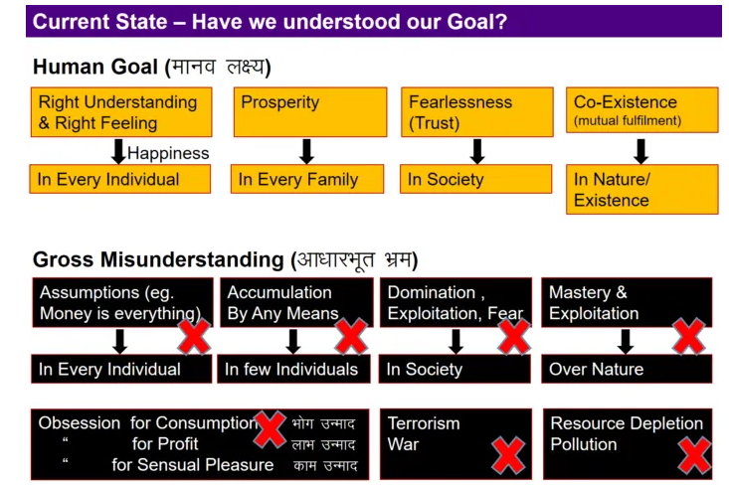

## Education – Right Living

On this account, we have progressed in terms of taking literacy to all corners of society. Information that was limited to a selected few has got spread to the masses. We have developed means of communication to reach out to every human being. Girls and boys, both are able to attain education. But, we need to relook at the content of education and the effect of this content on the living of human beings.

Certainly, we have progressed in terms of making education within reach to all, but the programs of education have become mere programs of literacy, training, and information transfer. The real mark of an educated human being, as we saw above, is that he/she is able to lead a happy and prosperous life in oneself, and be mutually fulfilling all around. But do we see this today? We find that the education programs of today are making individuals feel more dissatisfied and deprived. In the whole process, we just learn how to multiply physical facilities, without ever trying to make out how much is needed. Training and information transfer programs, including literacy programs, are of course required. But they are a small part of the whole education process; they are not the complete education. This needs to be understood by all of us.

As mentioned above, human education ensures understanding and living in harmony at all levels of human existence, from self to entire existence. We are missing in the very first level. Do we study about our own self in twenty years of our education and training?

## Health – Self Regulation

In this dimension, we have made progress in terms of reducing infant death, increasing the life expectancy through medication, removal of epidemics, implanting artificial parts in the body to support the functioning of the body, and so on.

These facilities are of course an asset. But as we understand, Sanyam is basic to Swasthya. Lack of understanding of the body as an instrument of the self (‘I’) coupled with the technological progress has led us to go for newer sources of sensual pleasures, irresponsible practices in living, etc. In place of being responsible to the body, we are relying more on medication. We are developing micro and nano-technologies to cure the smallest parts of the body, but we are producing new diseases day by day through irresponsible living.

## Justice – Preservation

In terms of justice, we have progressed on account of bringing every act of crime to the court of law. Every issue related to relationship can now be debated in the court of law. But is the court of law the place to get justice? If we look at the situation today, we find that we have thousands of courts and lawyers and they are all trying to settle injustice in relations. Judgments are passed and punishments are given. This does not ensure justice. In justice, there is mutual fulfillment for both parties.

The fulfillment of relationship at the level of individual and family is deteriorating. TV serials depict in great detail the bad state of our affairs and are creating large viewership for such things. At the level of nations, we have rising fears of destructive wars with growing innovations in science and technology. The competition and enmity between nations or communities are on the hike, the feeling of mistrust and fear in villages and cities is slowly growing. The number of legal suits is increasing exponentially, families are breaking for trivial gains, communal violence, and conflicts between factions of society are multiplying.

Regarding **Suraksha**, we can see from history how we humans have fared well in developing new technologies which have a high degree of utilization for mankind. We have explored new dimensions of science to get information about every corner of nature. But due to lack of understanding, we have misused them more than rightly using them. We can see that in terms of:

1. **Enrichment:** We have largely disturbed nature via chemicals and depletion of resources rather than enrich it. Urgent steps are needed to rectify this trend.
2. **Protection:** the natural resources have been depleted to a large extent, birds and animals are fast getting extinct, the forested areas are on the wane, pollution is on the rise, be it air pollution, water pollution, soil pollution, plastic pollution, and so on. We have produced bombs to destroy the earth multiple times while destroying even once is not desirable.
3. **Right utilization:** again, we have fared very poorly. Today is an era of consumerism and wastage. We produce many times more clothes, electronics, cars, watches, cell phones, etc. than we need. Managing all this production has become a major problem for us today. All we are interested in is having more and more of it (accumulation). Hence, instead of right utilization, we have ended up exploiting and disposing of vast amounts of natural resources.

## Production – Work

We have seen that nature is cyclic and enriching. How do we, as human beings, fare when it comes to interacting with nature? On this account, we have done very well in terms of making our production systems efficient and automated, reducing the time, material, and energy requirement in production, ability to produce a variety of complicated parts and mechanisms, reducing the dependence on natural processes, and so on.

But all of us know how we have multiplied the environmental problems in the process and how we have increased consumerism today. We have disturbed the ecological balance and our production activities have upset the cycles in nature. Let us take into account some more facts here:

### Cyclic – Acyclic

While nature’s processes are all cyclic (close-ended) our processes are acyclic (open-ended). If nature functions in such a way that all resources are continuously renewed and replenished (like water, manure in the soil, etc), man’s process depletes them.

For example, when we burn coal, it is a non-renewable resource. We can never again produce the coal we are burning today. This is what we mean when we say ‘open-ended’. This is true for all fossil fuels: petrol, diesel, coal. All these are being pulled out from the bottom of the earth and being consumed by us. There are two problems with doing this:

1. The utility of all these fossil fuels at the bottom of the earth is to keep the temperature on the earth’s surface in a steady state – from the heat in its own core, and the heat from the sun. By depleting fossil fuels, we are tampering with the ability of the earth to maintain its temperature. This is irreparable damage we are doing.
2. When we burn fossil fuels in enormous quantities, it pollutes the atmosphere and poisons the air we breathe. And our basic need, to keep the body healthy, is affected.

### Enriching – Not-enriching

Are we enriching nature, or are we not? Largely the answer is NO. Take the example of pesticides and fertilizers. It is common knowledge today that the land that has seen heavy use of chemical fertilizers becomes unfit for agriculture. And the pesticides are poisoning our own bodies and the animals and birds as well. In the process of moving towards a global economy, we have increased our technological capabilities and increased the production capacities of our industries and factories. In this process, we have managed to make extinct thousands of plant, animal, and insect species. The statistics on this are quite terrifying. We seem to be hurtling towards problems of great magnitude as we continue down the path of environmental destruction.

## Exchange – Storage

In terms of exchange and storage, we have developed efficient ways of selling and buying, sending, or receiving money and investing them to multiply faster than nature could ever do. Sitting with the laptop, we can purchase commodities across the world and invest our capital in distant markets. Profits can multiply overnight, and we can enter the list of trillionaires without any physical work. We can also store hoards of currency within a digital map.

But with these rising modes of exchange and storage, the exploitation of mankind and nature has shot up. The disparities have increased, and the madness for profit has become the general motivation.

The liquidity of money has of course helped us by providing a smooth mode of exchange. But it has created more problems than solutions. These problems are the outcome of our misperception in visualizing money which is a national entity to be the same as physical facilities which are tangible and are our real needs. It needs to be remembered that money is not a need in itself but only a mechanism to facilitate the exchange of physical facilities.

## Harmony from Family Order to World Family Order: Universal Human Order

The Sarvabhaum Vyawastha is the state of realizing the freedom of individuals in the context of this universe. Respect towards mankind and nature is a must to establish the universal order. Having understood the comprehensive human goal, we are able to be in harmony not only with human beings but also with the rest of nature. We are able to see that we are related to every unit in nature and ensure mutual fulfillment in that relationship. Working on the five dimensions of human endeavor in the light of right understanding, we are able to work for an orderly living of the human society, whose foundational unit is the family and the final destination is the world family.

***Undivided Society: “The feeling of being related to every human being.”***

***Universal Human Order: “The feeling of being related to every unit including human beings and other entities of nature.”***

## Undivided society (Akhand Samaj)

An undivided human-centric society is one of the higher human goals. Akhand samaj is the state of the society where all people of different religions and thought processes live together and work towards the betterment of the society.

Three activities can be performed to send the message of a holistic society:

### 1. Educating society through workshops, seminars and street plays

This is about organizing workshops, seminars, and street play at various levels in society. The activity may be carried out by N.G.O.’s but must receive the support of government organizations. These activities can be categorized into three types which include:

* Knowing the self
* Knowing the existence on basis of self
* Knowing the definite human conduct which is the contribution of self in existence.

### 2. Value education in educational institutions

Value education should be introduced in the current education system at all levels – primary school, secondary school, senior secondary school as well as college level.

### 3. Helping to apply values to the real world

Organizations – both government and non-government should open up counseling centers that can help their employees or the general public to apply values to real-life situations. It is about realizing the alternatives in life. Various individuals are on the way to self-exploration, finding their natural acceptance towards a holistic approach to life and realizing it at all levels starting from self (with knowledge) to family (with meaningful relationships), then to society (education – health – production – business – services). The idea is not to live in isolation or individualism but with the expansion of SELF to higher levels in the social system